Innovatech Solutions: Design Document
Case study 2

1. Introduction and scope
This document specifies how Innovatech Solutions' cloud-only environment from case study 1 becomes a hybrid, monitored and self-defending infrastructure: an AWS hub-and-spoke network joined by a site-to-site VPN to a simulated on-premises site, a Prometheus, Loki and Grafana monitoring stack, and an event-driven SOAR system.

Goals of this phase
- Connect an on-premises site securely to the previous AWS solution and resolve names across both sides.
- Collect logs and metrics from both environments in one monitoring stack and alert on them.
- Respond automatically to security alerts through a SOAR pipeline hosted in AWS, separate from the monitored workstations.
- Update every system centrally and repeatably, and deploy all infrastructure and SOAR code from a pipeline.

2. Requirements analysis
Theme | Requirements | What is demanded | Design decision
Resilience | P2-01 | Continued function or fast recovery after an isolated failure | Two availability zones for data, DNS and SOAR subnets; a queue between alert and action; documented failure tests
Isolation and access | P2-02, P2-03 | Segmented topology with controlled flows; no public exposure of databases | Hub-and-spoke on the Transit Gateway; one subnet per tier; reachability configured through security groups
Name resolution | P2-04 | Private service names resolve to private addresses | Route 53 private hosted zone, two DNS forwarders and the pfSense resolver
Monitoring | P2-06, P2-07, P2-09 | Evaluated stack; at least two log sources with alerting; SOAR health visible | Prometheus, Loki and Grafana, with CloudWatch as an extra data source; pfSense and Linux server logs
SOAR | P2-08 | Event-driven processing and automated actions, with monitored workstations on a different platform | SNS, SQS and Lambda in AWS; workstations on the on-premises site
Automation and delivery | P2-10, P2-11, P2-12, P1-05 | Declarative infrastructure, CI/CD from a local runner, a DevOps platform, centralised updates | Terraform, Ansible, a Git platform and a runner on the on-premises site

3. Hybrid network design
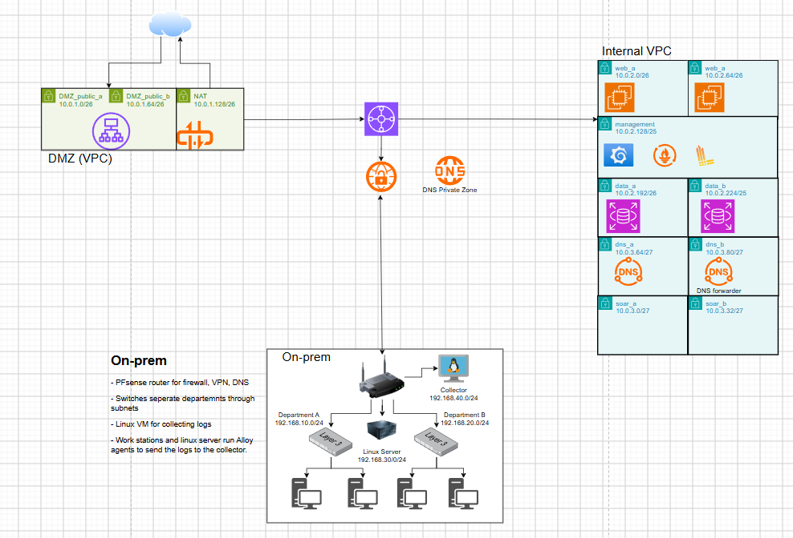

3.1 Address plan
No range overlaps any other, which the Transit Gateway and the VPN both require.
Site | Subnet | Range | Purpose
AWS, DMZ VPC | DMZ_public_a | 10.0.1.0/26 | ALB, AZ a
AWS, DMZ VPC | DMZ_public_b | 10.0.1.64/26 | ALB, AZ b
AWS, DMZ VPC | NAT | 10.0.1.128/26 | NAT gateway
AWS, internal VPC | web_a | 10.0.2.0/26 | Web tier, AZ a
AWS, internal VPC | web_b | 10.0.2.64/26 | Web tier, AZ b
AWS, internal VPC | management | 10.0.2.128/26 | Prometheus, Loki, Grafana
AWS, internal VPC | data_a | 10.0.2.192/27 | Database, AZ a
AWS, internal VPC | data_b | 10.0.2.224/27 | Database, AZ b
AWS, internal VPC | soar_a | 10.0.3.0/27 | SOAR Lambda, AZ a
AWS, internal VPC | soar_b | 10.0.3.32/27 | SOAR Lambda, AZ b
AWS, internal VPC | dns_a | 10.0.3.64/28 | DNS forwarder, AZ a
AWS, internal VPC | dns_b | 10.0.3.80/28 | DNS forwarder, AZ b
AWS, internal VPC | spare | 10.0.3.96 to 10.0.3.255 | Potentially to be used for the future
On-premises | Department A | 192.168.10.0/24 | Workstations
On-premises | Department B | 192.168.20.0/24 | Workstations
On-premises | Linux server | 192.168.30.0/24 | Server and log source
On-premises | Collector and management | 192.168.40.0/24 | Log collector, Ansible and runner VM

3.2 Segmentation
- AWS. The DMZ is its own VPC. Inside the internal VPC each tier has its own subnet, and traffic between tiers is controlled by security, plus one network ACL per tier.
- On-premises. pfSense has one interface per segment and denies traffic between segments by default, opening only the flows listed in 4.5.
- Why not more VPCs. The account limits the number of address ranges, and an extra VPC also adds a Transit Gateway attachment fee. Subnets with strict rules give the isolation the requirement asks for.

3.3 Site-to-site VPN
An IPsec VPN connects pfSense to a VPN attachment on the Transit Gateway. AWS provides two tunnels per connection, and routes are static.

3.4 Routing

Where | Destination | Next hop
Internal VPC subnets | On-premises ranges (192.168.10.0/24 to 192.168.40.0/24) | Transit Gateway
Internal VPC subnets | 0.0.0.0/0 | Transit Gateway, then the NAT in the DMZ
DMZ NAT subnet | 10.0.2.0/23 | Transit Gateway (return traffic)
DMZ public subnets | 0.0.0.0/0 | Internet gateway
Transit Gateway | 10.0.1.0/24 | DMZ VPC attachment
Transit Gateway | 10.0.2.0/23 | Internal VPC attachment
Transit Gateway | On-premises ranges | VPN attachment
Transit Gateway | 0.0.0.0/0 | DMZ VPC attachment
pfSense | 10.0.1.0/24 and 10.0.2.0/23 | IPsec tunnel

3.5 Firewalling
Three layers apply: pfSense rules on-premises, stateful security groups per tier in AWS, and stateless network ACLs per tier. Anything not listed is denied.
From | To | Port | Purpose
Internet | ALB | 80, 443 | Public web access
Servers and workstations | Collector | Log ingest port | Log shipping over the LAN
pfSense | Collector | Syslog port | Firewall logs
Collector | Loki (management subnet) | 3100 | Logs over the VPN
Prometheus | Exporters on VMs, both sites | 9100 | Metrics scraping
Ansible and runner VM | All managed VMs | 22 (WinRM for Windows hosts) | Configuration and patching
SOAR subnets | pfSense | 443 | Block action through the REST API, accepted from these two subnets
Web tier and management | Database | Database port | Application queries and Grafana backend
On-premises and all VPC subnets | DNS forwarders | 53, UDP and TCP | Name resolution

3.6 Private DNS
- A Route 53 private hosted zone, innovatech.internal, is associated with the internal VPC. It will hold records such as grafana, loki and db (an alias to the RDS endpoint).
- Two forwarders, in dns_a and dns_b, send queries for the on-premises zone to pfSense and everything else to the VPC resolver. The VPC's DHCP options point instances at both forwarders, so losing one is invisible.
- pfSense's resolver has a domain override that sends the AWS zone to the forwarders, and DHCP gives pfSense as the DNS server to every on-premises VM. No device needs its own cloud DNS settings.

4. Enhanced monitoring solution
Monitoring runs on Prometheus, Loki and Grafana in the management subnet, with CloudWatch added as a data source for the AWS-managed services that cannot run an agent.
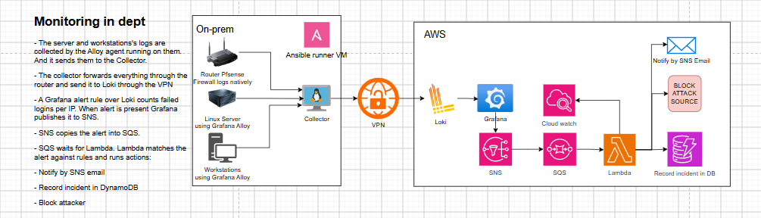
Every on-premises log passes through the collector and the VPN to Loki, and Grafana reads Loki, Prometheus and CloudWatch before it publishes alerts to SNS.

4.1 Log sources and data flow
The log sources are pfSense firewall logs, the Linux server's authentication and system logs, workstation logs (event logs if the workstations run Windows) and logs from the AWS VMs.
- Alloy agents on the Linux server and workstations push their logs to the collector.
- pfSense sends its firewall logs to the collector as syslog, because pfSense cannot run an agent and Loki does not accept syslog.
- The collector forwards everything through pfSense and the VPN to Loki.
- AWS VMs push to Loki directly.
- Prometheus scrapes exporters on VMs at both sites.
- Grafana queries Loki, Prometheus and CloudWatch.
If the tunnel or Loki is down, agents retry and file-based logs resume where they stopped. The pfSense syslog stream may lose messages during an outage, which is covered in the failure tests (section 9).

4.2 Alerting
Alert | Source | Condition | Result
SSH brute force | Loki, server authentication log | More than 5 failed logins from one address in one minute | Published to SNS and processed by SOAR
Firewall block burst | Loki, pfSense logs | Many blocked connections from one source in a short window; threshold set during testing | Published to SNS and processed by SOAR
SOAR dead-letter queue not empty | CloudWatch | One or more messages in the dead-letter queue | Email to the operator; this is a notification, not an automated response
Host down | Prometheus | A scrape target is unreachable for several minutes | Email to the operator

5. SOAR system
SOAR is an event-driven pipeline in AWS: Grafana publishes an alert to SNS, SQS buffers it, and a Lambda function matches it to a rule and runs the response actions.
The queue holds alerts until Lambda is ready, and anything that keeps failing lands in the dead-letter queue instead of being lost.

5.1 Data storage
One DynamoDB table with on-demand capacity stores incidents. The key is the source address plus the event time, with attributes for rule, severity, actions, outcome and block expiry.

6. Update method
Ansible, run from the runner VM on the on-premises site, patches every VM at both sites from one set of playbooks, with no manual step on any machine.
Target | How it is updated
On-premises Linux and Windows VMs | Ansible over the LAN (SSH, or WinRM for Windows)
AWS EC2 VMs | The same playbooks over the VPN, using private addresses
pfSense | Controlled manual upgrade, because the REST API package is tied to specific pfSense versions
RDS | Managed by AWS; the maintenance window is set in Terraform
Lambda, SNS, SQS, DynamoDB | Managed by AWS

Playbook flow. For each host group Ansible refreshes the package index, installs all available updates, reboots only when the system asks for it, waits for the host to return, and checks that the Alloy agent and the metrics exporter are running again. Hosts are patched in small batches, one availability zone at a time in AWS, so a reboot never takes down both copies of a tier.
Consistency and repeatability.
- The inventory has groups for on-premises and AWS hosts. AWS hosts come from Terraform outputs or the EC2 inventory plugin, and on-premises hosts from a file in the repository.
- The same roles install Alloy and the exporters, so a new VM is configured by running the playbook after Terraform creates it.
- Playbooks are idempotent, so running them twice changes nothing the second time.
- Access uses key-based SSH with a dedicated automation account that has only the sudo rights it needs.

7. Resilience and design for failure
Every tier that matters has either a second copy in another availability zone or a buffer that holds work until the failed part returns. Each scenario below is exercised in the test plan, which records the observed behaviour and recovery time.
Failure | Effect | Built-in protection | Recovery
Lambda function disabled or failing | Alerts are not processed | SQS keeps the messages | Fix or re-enable the function; the queue drains
Malformed alert message | Repeated processing failures | Dead-letter queue after a set number of tries; operator email | Inspect the message, then replay or discard it
One availability zone lost | Half of the web, DNS and SOAR capacity | Two subnets per tier; DNS clients list both forwarders; Lambda runs in both SOAR subnets | Automatic; rebuild the lost instances with Terraform and Ansible
Database instance failure | Application and Grafana backend unavailable | RDS Multi-AZ failover (enabled for the demonstration); automated backups | Failover, or restore from a snapshot
VPN tunnel down | On-premises logs stop reaching Loki; SOAR cannot block on pfSense | Two tunnels per connection; agents and the collector retry | Re-establish the tunnel; file-based logs resume, pfSense syslog has a gap
Collector VM down | All on-premises logs stop | Agents retry and file-based logs resume | Rebuild with Ansible; a second collector is the production fix
NAT gateway down | Grafana cannot publish to SNS; Lambda cannot reach AWS APIs | None: the NAT is a single instance, accepted for this project | Recreate the NAT; a NAT per availability zone is the production fix
Monitoring VM lost | No dashboards or alerting | Dashboards and settings stored in the database | Rebuild with Terraform and Ansible

